|  |
| --- |
| Day 13 assignments by lokesh nadella |

1.declare a 2d array of size(2,2) and initialize using indexes and print the value using nested for loop??

using System;

using System.Collections.Generic;

using System.Linq;

using System.Text;

using System.Threading.Tasks;

namespace day13_project1

{

internal class Program

{

static void Main(string[] args)

{

int[,] data =new int[2, 2];

data[0, 0] = 34;

data[0, 1] = 69;

data[1, 0] = 984;

data[1, 1] = 124;

for (int i = 0; i < 2; i++)

{

for (int j = 0; j < 2; j++)

{

Console.Write(data[i, j] + " ");

}

Console.Write("\n");

}

Console.ReadLine();

}

}

}

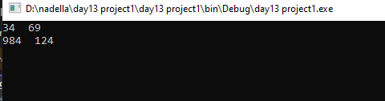

2.declare a 2d array of size (3,2) and iniatilize in the same line while declaring print the value using nested for loop??

using System;

using System.Collections.Generic;

using System.Linq;

using System.Text;

using System.Threading.Tasks;

namespace day_13_project_2

{

internal class Program

{

static void Main(string[] args)

{

int[,] data = new int[,] { { 56, 67 }, { 84, 43 }, { 11, 22 } };

for (int i = 0; i < 3; i++)

{

for (int j = 0; j < 2; j++)

{

Console.Write(data[i, j] + " ");

}

Console.Write("\n");

}

Console.ReadLine();

}

}

}

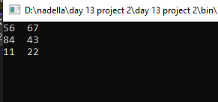

3.declare a 2d array of size(3,3) and print and trace array??

using System;

using System.Collections.Generic;

using System.Linq;

using System.Text;

using System.Threading.Tasks;

namespace day_13_project3

{

internal class Program

{

static void Main(string[] args)

{

int sum = 0;

int[,] data = new int[,] { { 5, 6, 7 }, { 8, 4, 3 }, { 11, 22, 33 } };

for (int i = 0; i < 3; i++)

{

for (int j = 0; j < 3; j++)

{

if (i == j)

sum = sum + data[i, j];

}

}

Console.WriteLine(sum);

Console.ReadLine();

}

}

}

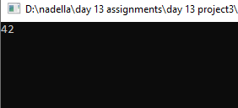

4.declare a 2d array of size(2,2) and read values from user and print array value???

using System;

using System.Collections.Generic;

using System.Linq;

using System.Text;

using System.Threading.Tasks;

namespace day_13_project4

{

internal class Program

{

static void Main(string[] args)

{

int[,] data = new int[2, 2];

for (int i = 0; i < 2; i++)

{

for (int j = 0; j < 2; j++)

{

Console.WriteLine("enter array value");

data[i, j] = Convert.ToInt32(Console.ReadLine());

}

}

for (int i = 0; i < 2; i++)

{

for (int j = 0; j < 2; j++)

{

Console.Write($"{data[i, j]} ");

}

Console.Write("\n");

}

Console.ReadLine();

}

}

}

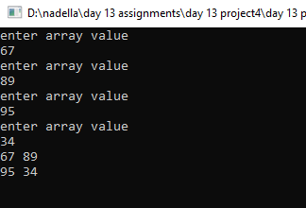

5.declare 2d array of size (2,2) and read values from user and print the sum of two matrices???

using System;

using System.Collections.Generic;

using System.Linq;

using System.Text;

using System.Threading.Tasks;

namespace day13_project5

{

internal class Program

{

static void Main(string[] args)

{

int[,] data = new int[2, 2];

for (int i = 0; i < 2; i++)

{

for (int j = 0; j < 2; j++)

{

Console.WriteLine("enter 1st array value");

data[i, j] = Convert.ToInt32(Console.ReadLine());

}

}

for (int i = 0; i < 2; i++)

{

for (int j = 0; j < 2; j++) { }

}

int[,] data2 = new int[2, 2];

for (int i = 0; i < 2; i++)

{

for (int j = 0; j < 2; j++)

{

Console.WriteLine("enter 2nd array value");

data2[i, j] = Convert.ToInt32(Console.ReadLine());

}

}

for (int i = 0; i < 2; i++)

{

for (int j = 0; j < 2; j++)

{

Console.Write(data[i, j] + data2[i, j] + " ");

}

Console.Write("\n");

}

Console.ReadLine();

}

}

}

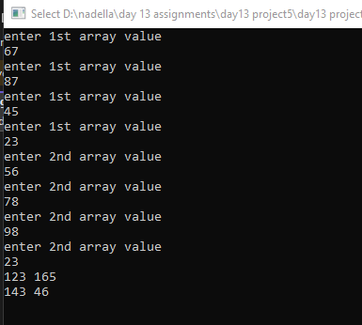

6.declare two 2d arrays of size(2,2) and read values from user and print the product of two numbers??

using System;

using System.Collections.Generic;

using System.Linq;

using System.Text;

using System.Threading.Tasks;

namespace day_13_project_6

{

internal class Program

{

static void Main(string[] args)

{

int[,] data = new int[2, 2];

for (int i = 0; i < 2; i++)

{

for (int j = 0; j < 2; j++)

{

Console.WriteLine("enter 1st array value");

data[i, j] = Convert.ToInt32(Console.ReadLine());

}

}

for (int i = 0; i < 2; i++)

{

for (int j = 0; j < 2; j++) { }

}

int[,] data2 = new int[2, 2];

for (int i = 0; i < 2; i++)

{

for (int j = 0; j < 2; j++)

{

Console.WriteLine("enter 2nd array value");

data2[i, j] = Convert.ToInt32(Console.ReadLine());

}

}

for (int i = 0; i < 2; i++)

{

for (int j = 0; j < 2; j++)

{

Console.Write(data[i, j] * data2[i, j] + " ");

}

Console.Write("\n");

}

Console.ReadLine();

}

}

}

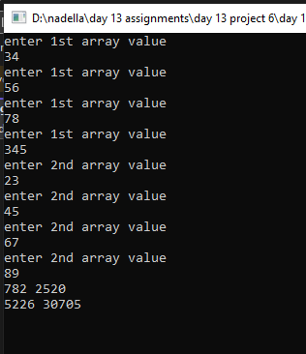

7.write a c# program to illustrate usage of <stack>???

using System;

using System.Collections.Generic;

using System.Linq;

using System.Text;

using System.Threading.Tasks;

namespace day13_project_7

{

internal class Program

{

static void Main(string[] args)

{

Stack<int> data = new Stack<int>();

data.Push(20);

data.Push(4);

data.Push(55);

data.Push(12);

Console.WriteLine(data.Count);

Console.WriteLine(data.Pop());

Console.WriteLine(data.Count);

Console.ReadLine();

}

}

}

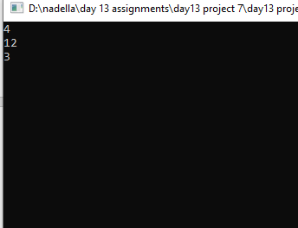

8.write a c# program to illustrate and usage of <queue> ??

using System;

using System.Collections.Generic;

using System.Linq;

using System.Text;

using System.Threading.Tasks;

namespace day_13_project8

{

internal class Program

{

static void Main(string[] args)

{

Queue<int> data = new Queue<int>();

data.Enqueue(24);

data.Enqueue(35);

data.Enqueue(45);

Console.WriteLine(data.Count);

Console.WriteLine(data.Dequeue());

Console.WriteLine(data.Count);

Console.ReadLine();

}

}

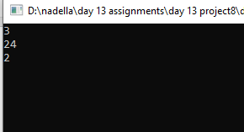

9.write a c# program and declare an array ??

using System;

using System.Collections.Generic;

using System.Linq;

using System.Text;

using System.Threading.Tasks;

namespace day13_project_9

{

internal class Program

{

static void Main(string[] args)

{

char[][] names = new char[3][];

names[0] = new char[] { 'l', 'K' };

names[1] = new char[] { 'l', '0', 'k', 'e', 's', 'h', 'n' };

names[2] = new char[] { 'S', 'i', 'v', 'a', };

for (int i = 0; i < 3; i++)

{

for (int j = 0; j < names[i].Length; j++)

{

Console.Write(names[i][j]);

}

Console.Write("\n");

Console.ReadLine();

}

}

}

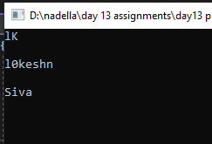

10. write a c# program and illlustrarte usage of recursion and benefits of recursion??

using System;

using System.Collections.Generic;

using System.Linq;

using System.Text;

using System.Threading.Tasks;

namespace day13_project_10

{

internal class Program

{

static void Main(string[] args)

{

int fact = 1;

Console.WriteLine("Enter a number:");

int num = int.Parse(Console.ReadLine());

for (int i = 1; i <= num; i++)

{

fact = fact * i;

}

Console.WriteLine($"fact of given number is:{fact}");

Console.ReadLine();

}

}

}

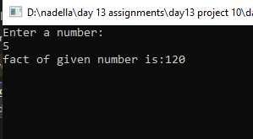

11. what is recursion??

A function which calls itself is known as recursion

12. what is jagged array and its benefits??

In jagged array each row have different size

Benefit : saving of memory